Boolean Expressions
Every control structure in this chapter has two distinct parts: the test (which determines
which part of the rest of the structure executes), and the dependent code itself (whether separate
branches or the body of a loop). Tests work by evaluating a Boolean expression, an
expression with a result treated as either true or false.
Boolean constants
The simplest kind of expression is a simple value, and the simplest Boolean values are the
constants TRUE and FALSE. We can use these constants anywhere we would use a more complicated
Boolean expression, and vice versa. For example, we can embed them in the test part
of an if-else statement:
if (TRUE)
print(“This will always print<BR>”);
else
print(“This will never print<BR>”);
Or equivalently:
if (FALSE)
print(“This will never print<BR>”);
else
print(“This will always print<BR>”);
The && and || operators will be familiar to C programmers. The ! operator is usually called not, since it negates(否定) the argument it operates on.As an example of using logical operators, consider the following expression:
(($statement_1 && $statement_2) ||
($statement_1 && !$statement_2) ||
(!$statement_1 && $statement_2) ||
(!$statement_1 && !$statement_2))
This is a tautology, meaning that it is always true regardless of the values of the statement variables. There are four possible combinations of truth values for the two variables, each of which is represented by one of the && expressions. One of these four must be true, and because they are linked by the || operator, the entire expression must be true.Here’s another, slightly trickier tautology using xor:
(($statement_1 and $statement_2 and
$statement_3) xor
((!($statement_1 and $statement_2)) or
(!($statement_1 and $statement_3)) or
(!($statement_2 and $statement_3))))
In English, this expression says, “Given three statements, one and only one of the following
two things hold—either 1) all three statements are true, or 2) there are two statements that
are not both true.”
Precedence of logical operators
Just as with any operators, some logical operators have higher precedence than others,although precedence can always be overridden by grouping subexpressions using parentheses.
The logical operators listed in declining order of precedence are: !, &&, ||, and, xor, or.
Actually, and, xor, and or have much lower precedence than the others, so that the assignment
operator (=) binds more tightly than and, but less tightly than &&.
Logical operators short-circuit(短路)
One very handy feature of Boolean operators is that they associate left to right, and they
short-circuit, meaning that they do not even evaluate their second argument if their truth
value is unambiguous from their first argument. For example, imagine that you wanted to
determine a very approximate ratio of two numbers, but also wanted to avoid a possible
division-by-zero error. You can first test to make sure that the denominator is not zero by
using the != (not-equal-to) operator:
if ($denom != 0 && $numer / $denom > 2)
print(“More than twice as much!”);
In the case where $denom is zero, the && operator should return false regardless of whether
the second expression is true or false. Because of short-circuiting, the second expression is
not evaluated, so an error is avoided. In the case where $denom is not zero, the && operator
does not have enough information to reach a conclusion about its truth value, so the second
expression is evaluated.
So far, all we’ve formally covered are the TRUE and FALSE constants and how to combine
them to make other true-or-false values. Now we’ll move on to operators that actually let you
make meaningful Boolean tests.
Comparison operators
Table 6-2 shows the comparison operators, which can be used for either numbers or strings
(although you should see the cautionary sidebar entitled “Comparing Things That Are Not
Integers”).

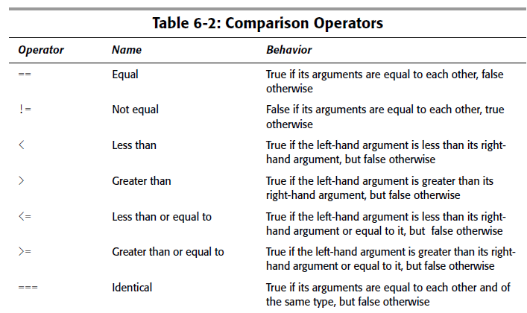
Operator precedence
Although overreliance on precedence rules can be confusing for the person who reads your
code next, it’s useful to note that comparison operators have higher precedence than Boolean
operators. This means that a test like the following:
if ($small_num > 2 && $small_num < 5) ...
doesn’t need any parentheses other than those shown.
String comparison
The comparison operators may be used to compare strings as well as numbers (see the
cautionary sidebar). We would expect the following code to print its associated sentence
(with apologies to Billy Bragg):
if ((“Marx” < “Mary”) and
(“Mary” < “Marzipan”))
{
print(“Between Marx and Marzipan in the “);
print(“dictionary, there was Mary.<BR>”);
}
The comparisons are case sensitive, and the only reason that this example will print anything
is because our values are case-consistent. Because of the capitalization of Dennis, the following
will not print anything:
if ((“deep blue sea” < “Dennis”) and
(“Dennis” < “devil”))
{
print(“Between the deep blue sea and “);
print(“the devil, that was me.<BR>”);
}
The ternary operator(三元运算符)
One especially useful construct is the ternary conditional operator, which plays a role somewhere
between a Boolean operator and a true branching construct. Its job is to take three
expressions and use the truth value of the first expression to decide which of the other two
expressions to evaluate and return. The syntax looks like:
test-expression ? yes-expression : no-expression
The value of this expression is the result of yes-expression if test-expression is true;
otherwise, it is the same as no-expression.
For example, the following expression assigns to $max_num either $first_num or
$second_num, whichever is larger:
$max_num = $first_num > $second_num ? $first_num : $second_num;

